TC-CMS-019
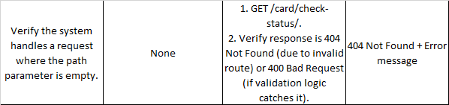
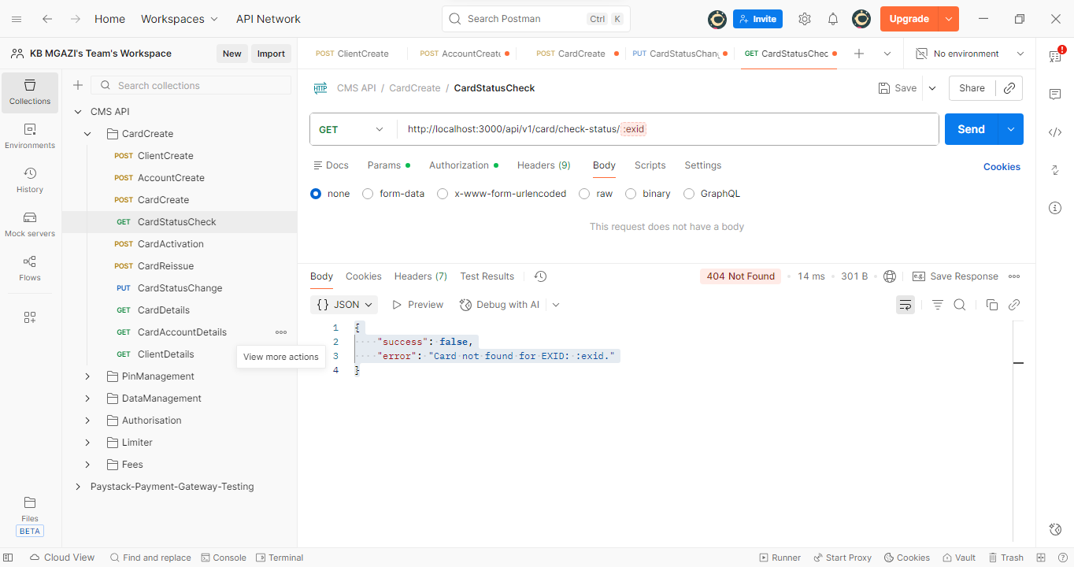
Response:
{
"success": false,
"error": "Card not found for EXID: :exid."
}

